Thursday Bidding Tips 11 Board 13 played on 12/7/2018 Burns Pairs
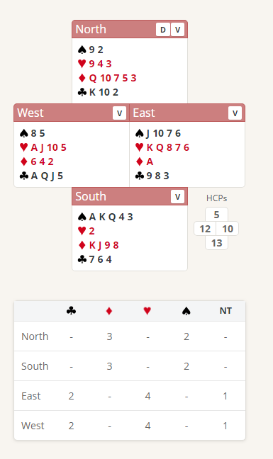
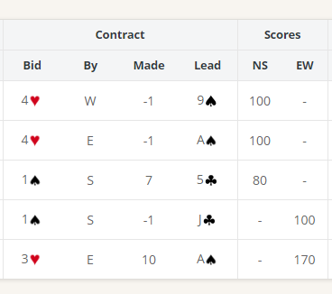

Suggested Bidding
N Dealer | E | S | W
pass | Pass | 1S | Double (X)
Pass | 3H | Pass | Pass
Pass

- Souths Bid of 1 Spade shows 12-19 Points and a 4-card spade suit
- Wests Double shows 12 plus points and a shortage in Spades,
Double (X)12+ HCP The double shows:
- an opening hand
- at least three cards in each of the unbid suits
- shortage in the opponent’s suit - usually a doubleton or fewer
- don’t double with length in the opener’s suit!
- North with 5 High Card Points and 2 Spades Passes
- East Bids 3 Hearts showing 10-12 Points and at least 4 Hearts
- West with only 12 points passes - worst case the EW partnership has 22 Points (12 plus 10) not enough for game, at best 24 points also not enough for game (If East has 13 points they should jump to game)
Suggested Lead from Ace Spades top of sequence

Further notes about Doubles
http://www.nzbridge.co.nz/user/inline/2648/NZB%20Beginner%2008%20-%20Student%20Notes.pdf

